The Secretary
An Coimisiún Pleanála
64 Marlborough Street
Dublin 1

10th October 2026

Re: Planning & Development Act 2000 and the Statutory Regulations made thereunder (as amended). Third party appeal by Jim and Mairead Lynch, Lynbyrn, Saval Park Road, Dalkey, Co. Dublin, A96 AY11 against the decision of Dun Laoghaire-Rathdown County Council to grant permission for development consisting of the demolition of the existing dwellinghouse and all associated structures on the site to allow the construction of four new residential dwellinghouses, consisting of a new part-one/part-two-storey 2-bed semi-detached unit & a new 3-storey 3-bed semi-detached unit both addressing Saval Park Road, and two new two-storey semi-detached 3-bed dwelling-houses to the rear of the site; all accessed via a widened pedestrian and vehicular entrance on Saval Park Road in the location of the existing vehicular entrance , private garden spaces to each unit, 4 no. off-street parking spaces and all associated site & drainage works at Lillegard, 1 Saval Park Road, Dalkey, Dublin, A96EC56.
Dun Laoghaire Rathdown County Council Planning Ref. D26A/0149/WEB
Date of Dun Laoghaire Rathdown County Council decision: 14th September 2026
Four week period for making appeal: on or before end of 12th September 2026

Dear Sir / Madam

We, Jim and Mairead Lynch, Lynbyrn, Saval Park Road, Dalkey, Co. Dublin, A96 AY11 wish to submit the following third-party appeal to An Coimisiún Pleanála against the decision of Dun Laoghaire Rathdown County Council to grant permission, for the above-described development.
We enclose herewith payment the sum €220 statutory appeal fee and a copy of the relevant letter of acknowledgement from the Planning Authority.
We submit that the grounds for overturning this decision and refusing permission in this instance are clear and unambiguous. We submit that the proposed development conflicts with the policies and objectives of the Dun Laoghaire-Rathdown County Development Plan 2022-2028 (CDP).
We respectfully submit that the nature of the current proposal be considered in two parts. The two houses to the rear, to be considered having regard to the backland policy of the CDP; whilst the replacement of the existing bungalow with houses 1 and 2 be considered having regard to replacement of an existing dwelling. We note that the CDP also states that residential development within the boundary of larger detached houses does not constitute backland development. We submit that this is not a large detached house but a bungalow, within a row of similar bungalows, within a site of 830sqm, that measures just over 14m in width.
The site of the proposed development is in an area :carrying a Zone A designation the objective of which is to "provide residential development and improve residential amenity while protecting the existing residential amenities". Whereas the proposed development increases residential density it fails to protect existing residential amenities.
The following points form the basis of our appeal: (we have not included any supporting documents in this respect as same formed part of our original submission)

- Fails to protect the established character of the surrounding area
The stated application details a haphazard development of an inappropriate layout, design and scale that falls short of the highest standards required by the CDP. The incongruous rooflines, road facing rear facades and rear gardens of houses 1 and 2 fail to integrate into the existing 19th/20th century streetscape and maintain the established character of the surrounding area. The proposed development also fails to respect the height and massing of adjoining residential units and is therefore contrary to Policy Objective PHP20 that seeks to protect residential amenity adjoining infill developments.
The design of the houses backing onto the street along Saval Park Road reflects the poorest consideration of urban design contrary to Policy PHP19 of the CDP. The design form of the two front houses is completely ad-hoc and forms an incongruous streetscape feature that should be refused.
If permitted, the proposed development would set an undesirable precedent for similar development in the area.
We also refer the Commission to the decision under Ref. D25A/0094/WEB that was refused for the demolition of the existing house, and construction of seven houses on a site of 1,356sqm (almost twice the size of the appeal site) at 156 Avondale Road, Killiney. The single reason for refusal was cited as:
“Having regard to the proposed design scheme including site layout, access and dwelling typologies, it is considered that the proposed development fails to provide the best design scheme for the subject site, having regard to the capacity and location of the site as well as the character and built form of developments in the surrounding area. To permit the proposed development would seriously injure the residential and visual amenity of the area, would result in an undesirable precedent for other similar inappropriately designed schemes, which would be contrary to the land use zoning objective 'A' of the site as set out in the Dun Laoghaire-Rathdown Development Plan 2022-2028, as well as the policy objectives set out in this plan, including Policy Objective PHP20: Protection of Existing Residential Amenity that seek developments to achieve a reasonable balance in protecting established residential amenities and providing a high density compact form of development in appropriate locations. The proposed development would, therefore, be contrary to the proper planning and sustainable development of the area.”
- Overdevelopment of the site
The proposal seeks to accommodate four dwellings on a constrained suburban site replacing a single existing dwelling. The proposed layout is overly intensive, with reduced separation distances, limited private open space and a compressed arrangement of buildings.
The first-floor bedroom windows of houses 1 and 4 are only 13.75m apart and therefore are materially in contravention with SPPR1 of the Sustainable and Compact Settlements: Guidelines for Planning Authorities.
The autotrack/swept path analysis also indicates the closeness of some of the turning movements to other spaces reflective of the overdevelopment being proposed.
- Inappropriate backland development
Units 3 and 4 create a second tier of development that does not conform with the prevailing pattern of development on Saval Park Road and contravene the standards for backland development, as set out under section 12.3.7.6 of the CDP. This states that backland development shall generally be single storey in height to avoid overlooking and be of high-quality design. The two rear houses meet neither criterion. Failure to adhere to these standards would set an unfavourable precedent for the similar piecemeal development of rear gardens along the road.
- Fails to protect existing residential amenities
The scale, intensity and layout of the development will cause our home and nearby properties to be seriously overlooked both internally and externally leading to an alarming reduction in privacy and loss of existing residential amenity. In this respect we would refer the Commission to the fact that the Council case planner failed to consider the single-story specification applying to backland development, as set out under section 12.3.7.6 of the CDP 2022-2028, when making their assessment. Units 3 and 4 are indicated as having three-bedrooms plus large study (4-bedroom equivalent), are c. 140sqm in area and 10.63m high along the boundary of the site. The height, scale and design of these rear houses constitute a visual intrusion and overbearing impact that coupled with visible 1st floor windows will generate an unacceptable loss of amenity.
We would also like to point out that the architectural drawings submitted with the application do not provide side elevations for houses 3 and 4. Clarification was not sought by the case planner.
- Additional traffic hazard
Proposed development will result in the generation of extra vehicular traffic at Saval Park Road opposite the large housing development known as Saval Park Gardens creating an additional traffic hazard. The overdeveloped and congested layout of the proposed development combined with the restricted access road could necessitate vehicles having to reverse out on to Saval Park Road opposite the entrance to Saval Park Gardens.
Saval Park Road is a busy commuter artery and the junction with Saval Park Gardens is located nearly opposite the site. We respectfully submit that the proposed access, even if widened, will still be deficient in terms of visibility splays and fail to meet the criteria outlined by Design Manual for Urban Roads and Streets (DMURS).
We refer the Commission to the decision made under Planning Ref. D23A/0298 / ACP Ref. ABP-319715-24, which was for the construction of four dwelling units to the rear of No. 72 Albert Road Upper. The application was refused by the Commission on traffic grounds as it would endanger public safety by reason of traffic hazard and would lead to conflict between road users, that is, vehicular traffic, pedestrians and cyclists within the scheme in the vicinity of its entrance onto Albert Road Upper but also within the public domain of Albert Road Upper.
- Fails to provide adequate parking
The proposed development only makes allowance for four parking spaces. This part of Saval Park Road is already congested with parking for DART users and shoppers at Barnhill Stores a situation which will be aggravated by the inadequate parking provided for in the proposed development.
- Principle of development and climate action
Policy Objectives CA5, CA6, CA8, PHP 19 and section 12.3.9 of the CDP favours the reuse of existing buildings rather than their demolition. We submit that the structural survey submitted by the applicant does not provide adequate justification to meet the threshold for the demolition in terms of the two houses that would replace it.
- Inconsistencies in planning documentation
The structural survey incorrectly claims that the existing dwelling is derelict. We note that the property generally remains sound and was in continued occupation until the date of sale. The same report also erroneously refers to the property as a semi-detached two-story building. It is in fact a bungalow with windows in the front and rear gables allowing the attic space to be used as a bedroom.
9. Decision of the Council
The Council issued a decision to grant permission on the 14 September 2026. The decision was subject to 11 conditions, none of which materially altered the nature and extent of the proposed development. We respectfully submit that the case planner, in making their decision, has made some statements that could be construed as inaccurate.
- They refer to their being provision for a ‘high-quality communal open space on the site’ when there is none.
- This is not a ‘City - Urban Neighbourhood’ area but forms a ‘City - Suburban/Urban Extension’ area as defined by the Compact Settlement Guidelines.
- No assessment of the qualitative nature of the private rear gardens of units 1 and 2 of the proposal that back onto Saval Park Road has been undertaken.
- No clarity was sought in terms of the clear conflict between the front boundary wall and hedge that is indicated as being retained. This hedge would appear to be largely within the public domain and would be impacted by the construction of the front wall.
- There is no cited rationale to support the case planner’s assessment as the proposed development being ‘consistent’ with neighbouring properties.
- No justification is given for their subjective opinion that the development’s ‘distinctive appearance’ would be a positive feature and add to the visual interest and variety to the street.

We respectfully submit that the proposed development, by nature of its scale, density, design and layout at this location amounts to a haphazard form of development that is contrary to the proper planning and sustainable development of the area and would be seriously injurious to the amenities of the area, and to us as owners of a house to the south of the proposed development site. On this basis we request that the Commission overturn the decision of the County Council and refuse planning permission for this development.

Yours faithfully,

Mairead and Jim Lynch
Mob. 086 0666910

Encl. Letter of acknowledgement from Dun Laoghaire Rathdown Co. Co. dated 1 April 2026.

Appendix 1 – Character of surrounding area
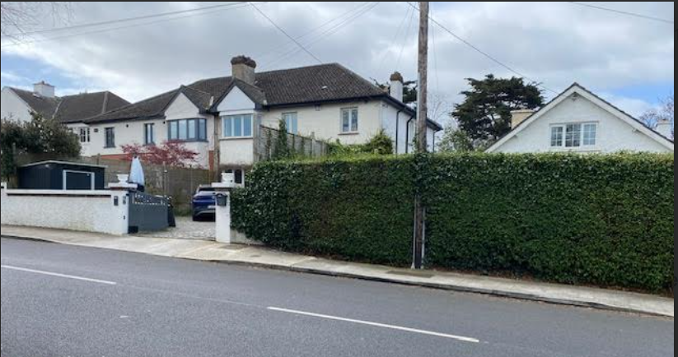
Existing streetscape

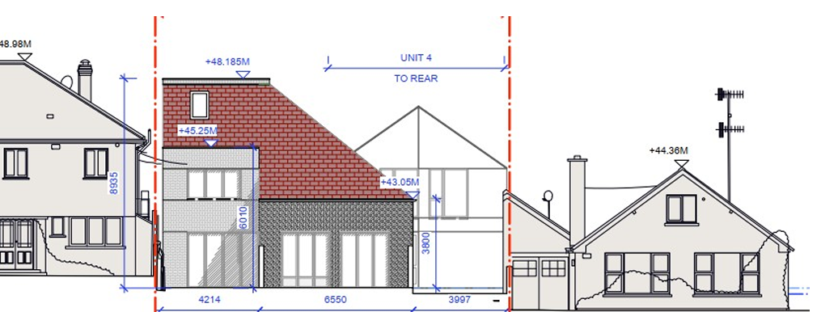
Incongruous appearance of the proposed development in terms of the existing streetscape
Appendix 2 - Negative impact on residential amenity

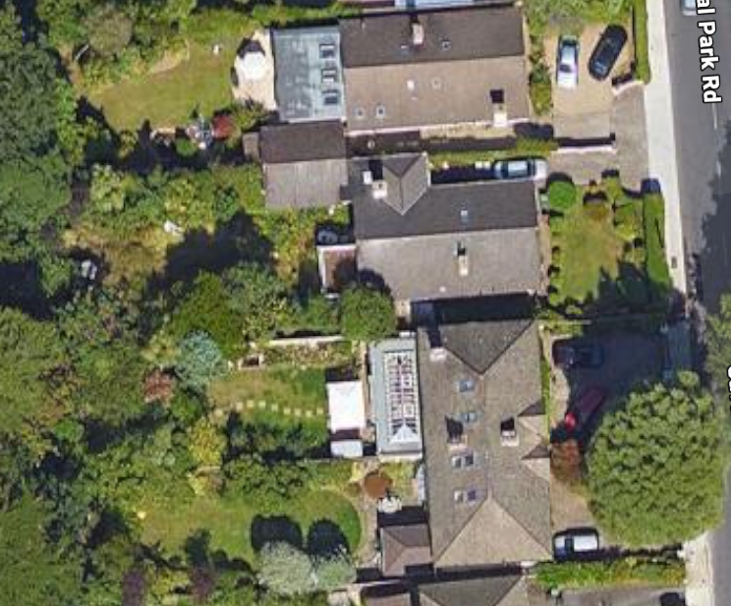
Aerial view of application site (outlined in yellow) and our home, Lynbyrn, to south (outlined in red) (Source: Google Maps)

Appendix 2 ctd

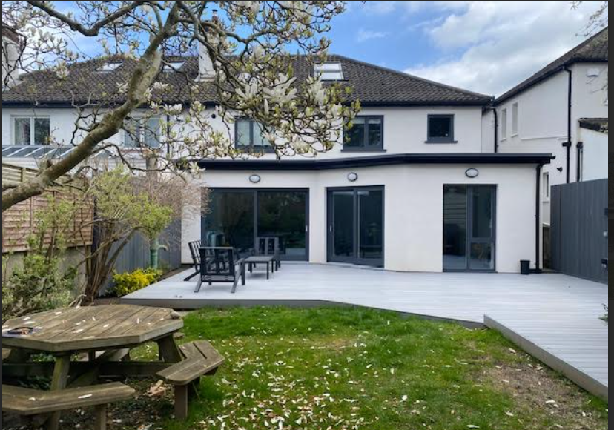
Rear elevation Lynbyrn, Saval Park Road

Appendix 2 ctd.

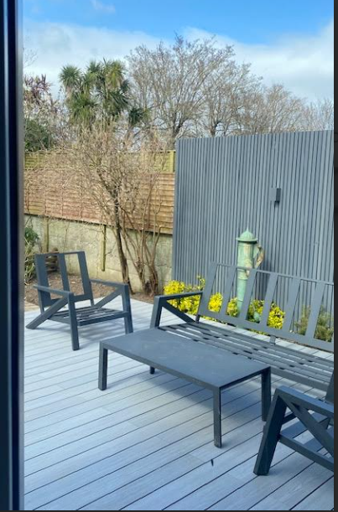
Location of proposed backland development, picture taken from inside the patio door. Arrow indicates the approximate position of house no. 3.
We respectfully submit that the scale and position of houses would be highly overbearing when viewed from our property. Any use of the rear garden of Lynbyrn will become heavily compromised and restricted, resulting in a serious diminution of our residential and visual amenity. We are especially concerned by the extent to which all windows to the rear of our property are overlooked resulting in a serious infringement in terms of the internal and external privacy of our home.
The overbearing nature of the proposal would be contrary to Policy Objective PHP20 of the County Development Plan and should be refused.
Appendix 3 - Creation of additional traffic hazard

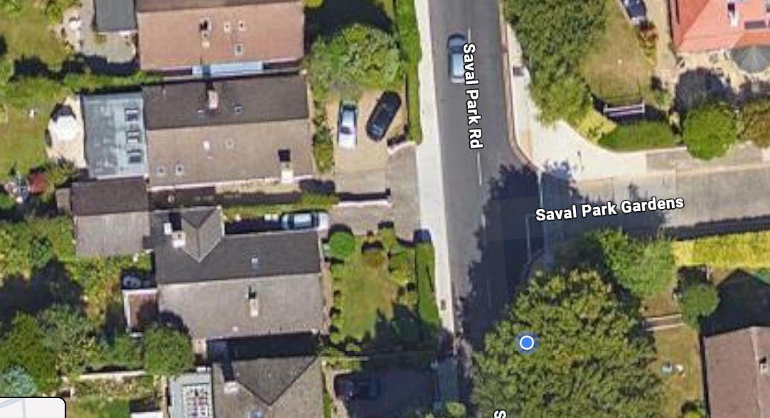
Proposed development site showing exit onto Saval Park Road at junction of Saval Park Gardens
Appendix 4 - Inconsistencies in planning documentation

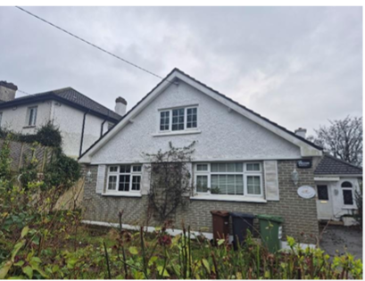
Front elevation Lillegard clearly showing a bungalow with window in gable

